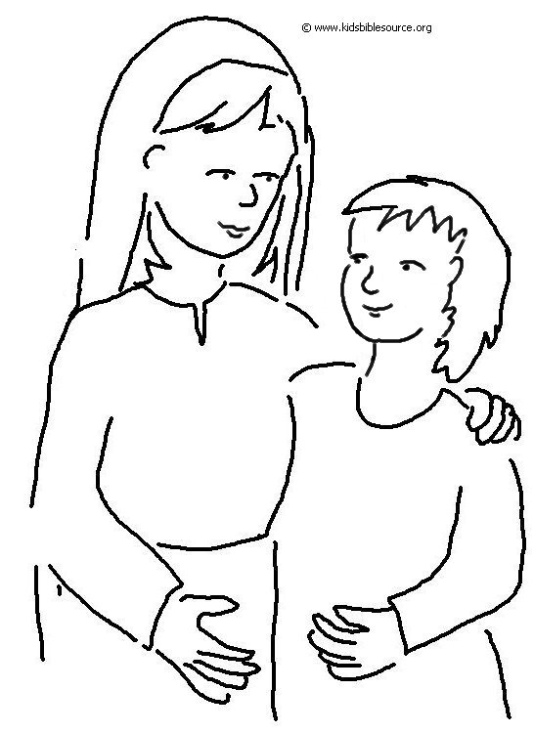
Even _ _ _ _ _ _ _ _ are known by the way they _ _ _, whether their conduct is pure, and whether it is _ _ _ _ _. Proverbs 20:11_{NLT}

